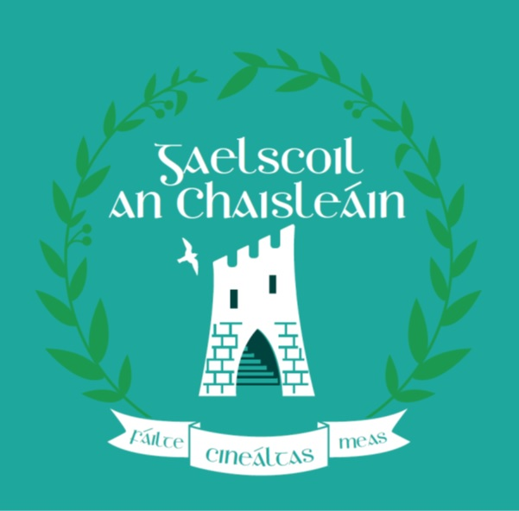
Gaelscoil an Chaisleáin
FÓGRA BLIANTÚIL MAIDIR LE LIGEAN ISTEACH
i dtaca le ligean isteach i scoilbhliain 2023/2024
Polasaí um Ligean Isteach agus Foirm Iarratais
Tá cóip de Pholasaí na scoile um Ligean Isteach agus Foirm Iarratais um Ligean Isteach do 2023-24 ar fáil mar seo a leanas:
Le híoslódáil ag: www.gaelscoilanchaisleain.ie
Ar iarratas: Ach ríomhphost a chur chuig gsanchaisleain@gmail.com nó scríobh chuig: Gaelscoil an Chaisleáin, Cumann Rugbaí Bhaile an Chollaigh, Páirc Tanner, Cul Rua, Baile an Chollaigh, P31 DA 38
CUID 1 - Ligean isteach i scoilbhliain 2023-24
Dátaí Iarratais agus Cinnidh i gcomhair ligean isteach in 2022-23
Is iad seo a leanas na dátaí is infheidhme maidir le ligean isteach sna Naíonáin Shóisearacha

Tosóidh an scoil ag glacadh le hiarratais i gcomhair ligean isteach ar | 03 .10.22
Stopfaidh an scoil ag glacadh le hiarratais i gcomhair ligean isteach ar | 28.10.22
Is é an dáta faoina gcuirfear an cinneadh maidir lena n-iarratas in iúl d’iarratasóirí ná | 11.11.22
Is í an tréimhse nach mór d’iarratasóirí a dheimhniú go bhfuil siad ag glacadh le tairiscint ar ligean isteach laistigh di ná | 18.11.22

Nóta: Measfaidh an scoil iarratais dhéanacha agus eiseoidh cinntí orthu de réir polasaí iontrála na scoile.

Líon na n-áiteanna atá á gcur ar fáil in 2023-24

Is é líon na n-áiteanna atá á gcur ar fáil sna Naíonáin Shóisearacha | 01.10 28

Gaelscoil an Chaisleáin
ANNUAL ADMISSION NOTICE
in respect of admissions to the 2023-24 school year
Admission Policy and Application Form
A copy of the school’s Admission Policy and the Application Form for Admission for the 2023-24 school year is available as follows:
To download at: www.gaelscoilanchaisleáin.ie
On request: By emailing gsanchaisleain@gmail.com or writing to: Gaelscoil an Chaisleáin, Cumann Rugbaí Bhaile an Chollaigh, Páirc Tanner, Cúl Rua, Baile an Chollaigh

PART 1 - Admissions to the 2023-24 school year

Application and Decision Dates for admission to 2023-24 school year.
The following are the dates applicable for admission to Junior Infants

The school will commence accepting applications for admission on | 03 .10.22
The school shall cease accepting applications for admission on | 28.10.22
T The date by which applicants will be notified of the decision on their application is | 11.11.22
The period within which applicants must confirm acceptance of an offer of admission is | 18.11.22

Note: the school will consider and issue decisions on late applications in accordance with the school’s admission policy.

Number of places being made available in 2021-22

The number of places being made available in Junior Infants | 01.10 28

